Sustainable and Climate Resilient Gurgaon – Resources and Actions

Minutes of meeting dated April 18, 2016
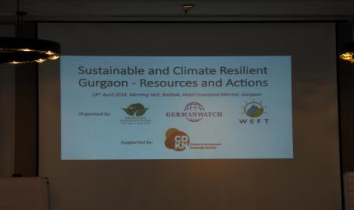

Objectives

- To assess the finance needs for climate compatible development (CCD) in second-tier cities in developing countries like India
- To analyze the extent to which existing sources can meet those needs
- To look at innovative local, national and international sources including direct access, modalities for cities under the Green Climate Fund (GCF)

Workshop audience

There were around twenty participants in the workshop. These included people from diverse backgrounds such as local NGOs, resident welfare associations, and more importantly, the elected representative and Councillor of the Municipal Corporation of Gurgaon, Ms. Nisha Singh also graced the event. (the list of participants is annexed at the end of the document)

Discussion

The 3-hour workshop began with welcoming the participants and introducing them to the goals and purpose of the project and the workshop. This was followed by a discussion on key challenges confronting Gurgaon.

Some of the key points that emerged as challenges facing Gurgaon are:

- Acute water scarcity coupled with poor water quality
- Gurgaon converted into a concrete jungle with shrinking green spaces
- Growing traffic and poor public infrastructure
- High levels of pollution, leading to increase in incidence of asthma and lung problems.
- Increasing consumption of electricity, due to extreme heat and high humid conditions, and high dependence on diesel gensets due to frequent power cuts.
- Vast areas of Gurgaon are being turned in to open landfills of waste, which not only leads to huge stench levels, but also increase in the breeding of mosquitoes, houseflies and other insects.
- High incidence of diseases such as Dengue and Malaria, which were non-existent particularly in high rise buildings
- Till recently, Gurgaon was known as the supplier of fresh vegetables and agricultural products for the entire Delhi and National Capital Region. But, due to massive land use patterns, most of the agricultural land has been converted to urban sprawls.

The second half of the workshop was spent in identifying the solutions and resources to address the problems.

The three broad areas that participants felt the need for prioritization are:

- Low carbon energy development including transportation
- Water and sanitation
- Increasing green (lung) space

Specifically, the following were some of the solutions that were prioritized under the above broad categories.

A1. Implementation plan for installation of solar roof tops for all buildings in Gurgaon for at least partial replacement of diesel generator sets which will avert fossil fuel use and pollution. There is also a possibility of payback to be built into such a project due to zero fuel cost once solarisation is in place. Barrier – lack of clarity on the policy around net metering.
A2. Implementation of LED lighting for all buildings in Gurgaon, with Malls, industry and corporate houses and all-star rated hotels being mandated to install LED lights immediately
A3. More viable and people-friendly public transport and creation of a “green zone” where only battery operated buggies can operate.

For instance, Electric Jeepneys or eJeepneys, the first of its kind public transport, were launched in Makati, Philippines in 2008. These eJeepneys run on pure electricity supply by rechargeable automotive batteries, thus it does not consume gasoline or diesel to operate. It, therefore, has no noise, no fumes, no harmful emissions.

B1. Enforcement of mandatory rain water harvesting for all buildings.
B2.Enforce and implement Water metering followed by right-pricing of water resource

C1. Impose restrictions on land use changes in the Aravalli green zone.
C2. Make it mandatory for all new buildings to have a dedicated green lung space (Gardens, play area etc)

Having identified a few areas, the third session explored sources of financing that could be accessed through domestic and existing sources, international sources including the Green Climate Fund. The presentation that followed listed out some of the fiscal instruments that could potentially be a source of revenue for climate proofing Gurgaon, based on experience and examples from other countries.

The final session deliberated on the next steps and the way forward. Some of these next steps agreed upon are listed below:

- Establishing a Gurgaon Project Core Group comprising representatives of RWAs, community clusters, including elected representatives.
- Through continued dialog and stakeholder engagement, accomplish the following:
2a) Identify priority projects that could be implemented as a community initiative
2b) Identify projects that could be pursued by communities and governments together
2c) Prioritize projects where preferably the government should take the lead

This would entail preparation of project plan, identification of sources of financing, accessing the financing and a detailed implementation plan.

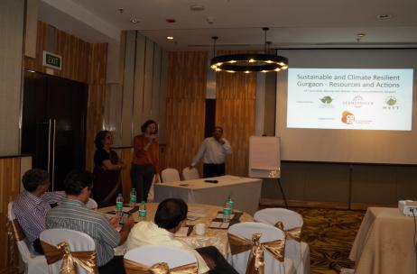

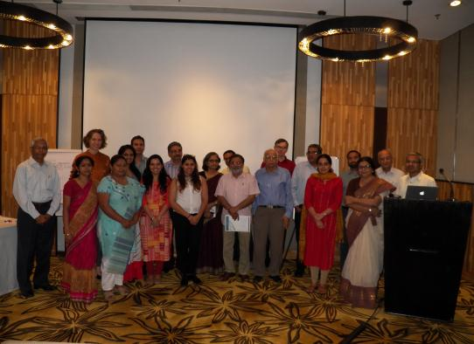

Name of the Participant | Organization
Aditi Paul | CDKN
Dr. Aparna Basu | Formerly NISTADS
Arun Jain
Arun Malhotra | Zenith Consulting
Chandramouli | Advit Foundation
Harish Kapoor | Resident of DLF Phase 1 and a retired CA
H C Khemani | Pluss Adv Tech Pvt Ltd
Joydeep Gupta | The Third Pole
Nisha Singh | Municipal Corporation of Gurgaon
Parimal Bardhan | HBRC, DLF Phase I
Samit Jain | Advit Foundation
Lisa Junghans | German Watch
Martin Welp | Eberswalde University for  Sustainable Development
Rekha Krishnan | WEFT Research
Srinivas Krishnaswamy | Vasudha Foundation
Raman Mehta | Vasudha Foundation
Indu Chinta | Vasudha Foundation
Samiksha Dhingra | Vasudha Foundation
Bhavya Sharma | Vasudha Foundation
C P Jayasree | Vasudha Foundation
Ratan Malla | Vasudha Foundation

